

**Advanced Web Engineering (AWE) Assignment Component 1.**

**Level – 6 (First Semester)**

**Submitted By: Shreejan Acharya Submitted To: Pratik Shrestha**

**University ID : 77229146 (Module Tutor)**

**Development Choice: Sublime Text**

**Screenshot of IDE with project code open in IDE.**

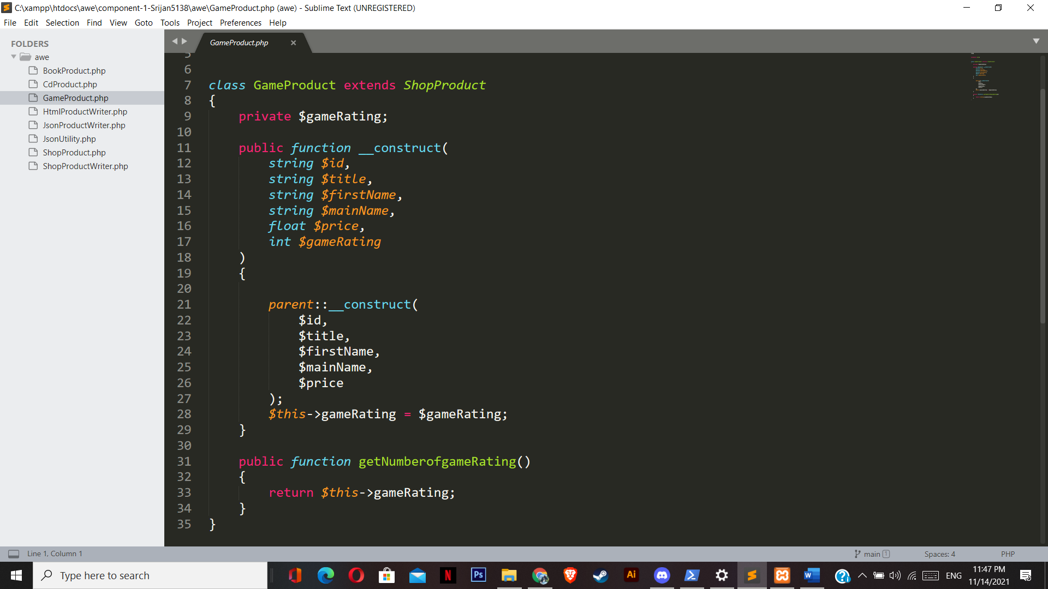

**Xampp installed.**

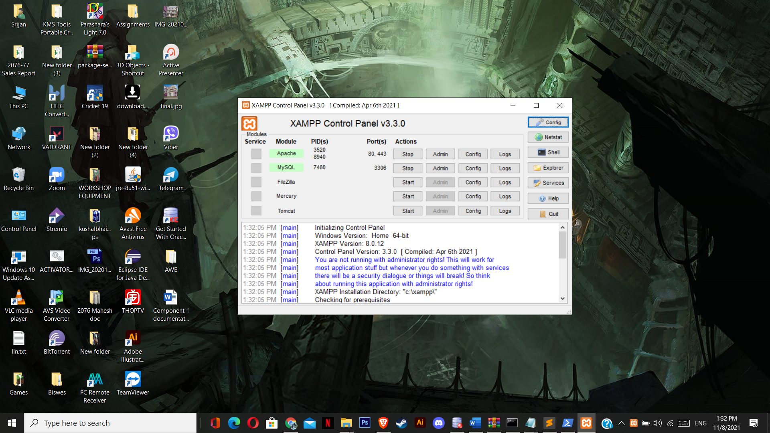

**Php version 8.0.12 installed.**

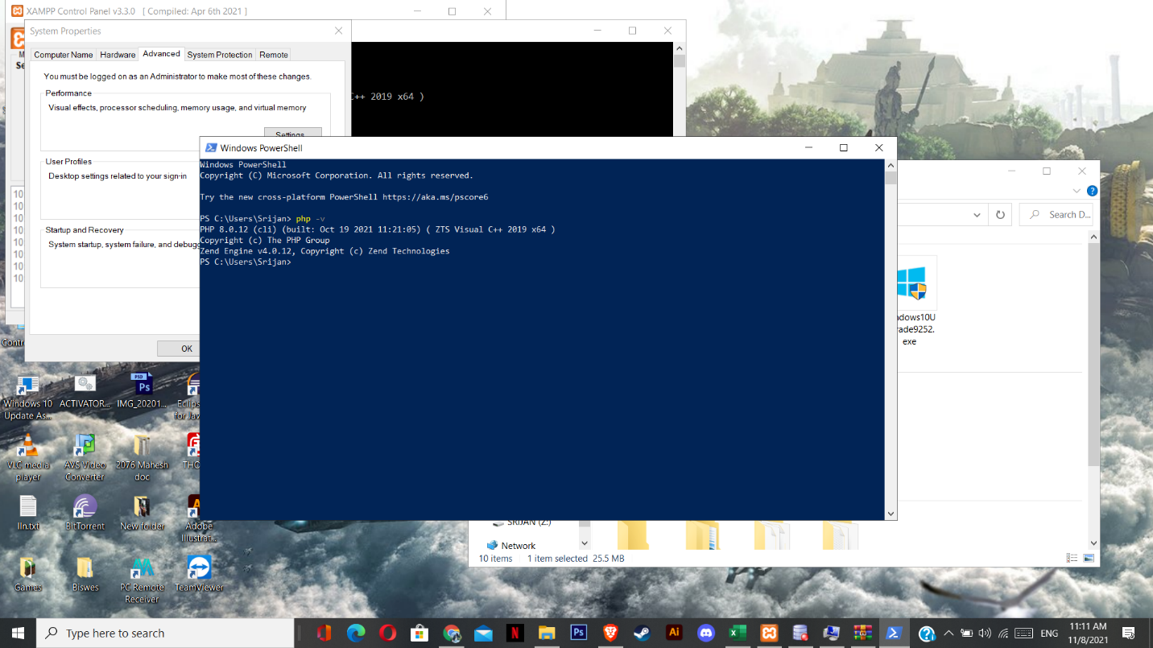

**Github account component 1 repository link.**

<https://github.com/tbc-bsc-l6/component-1-Srijan5138.git>

**Composer installed.**

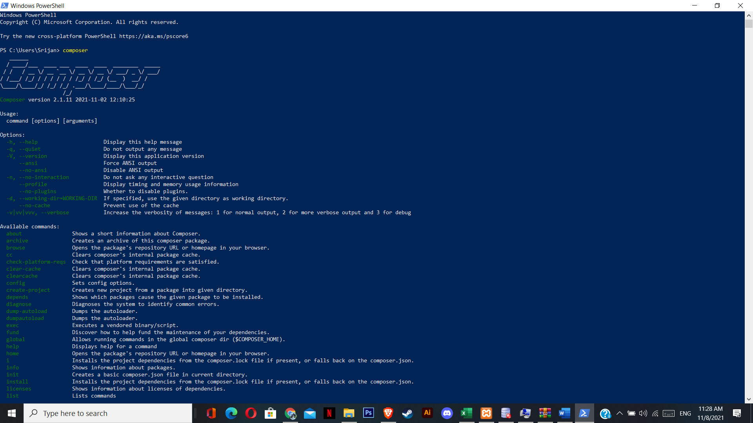

**Xdebug installed.**

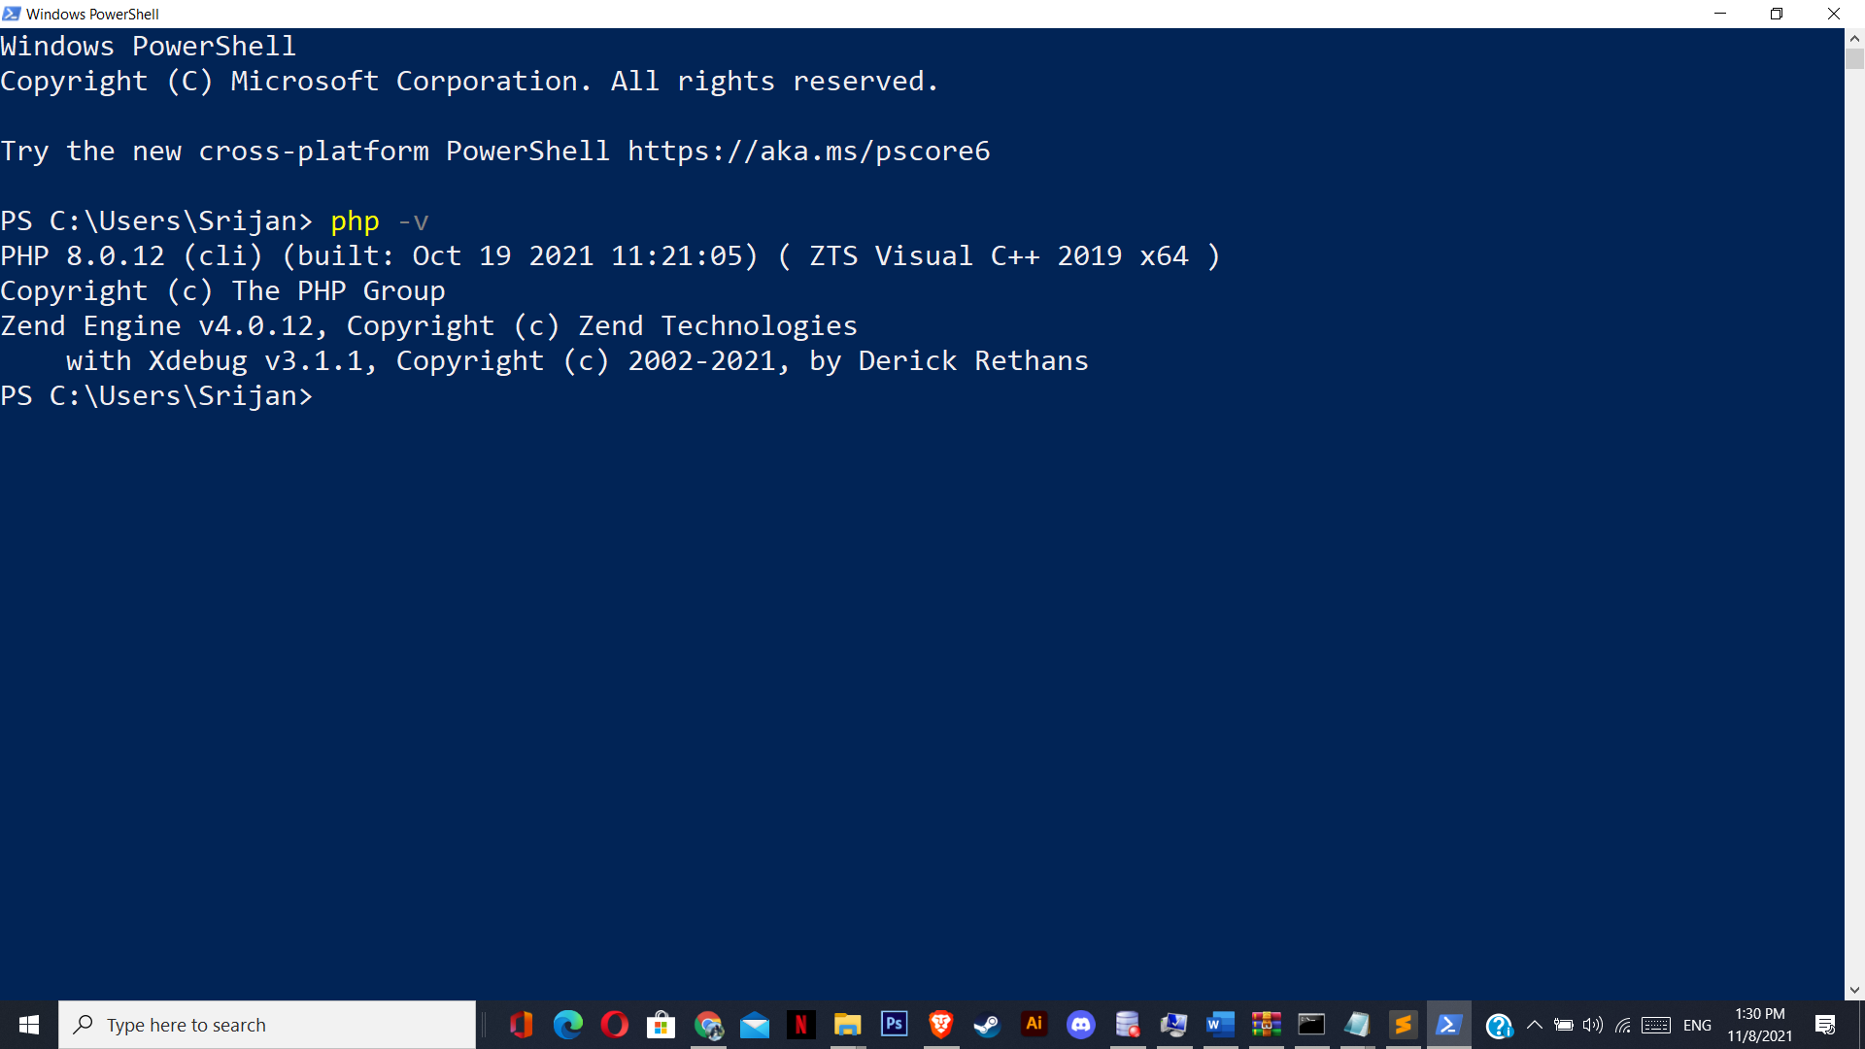

**Xdebug set up in xampp.**

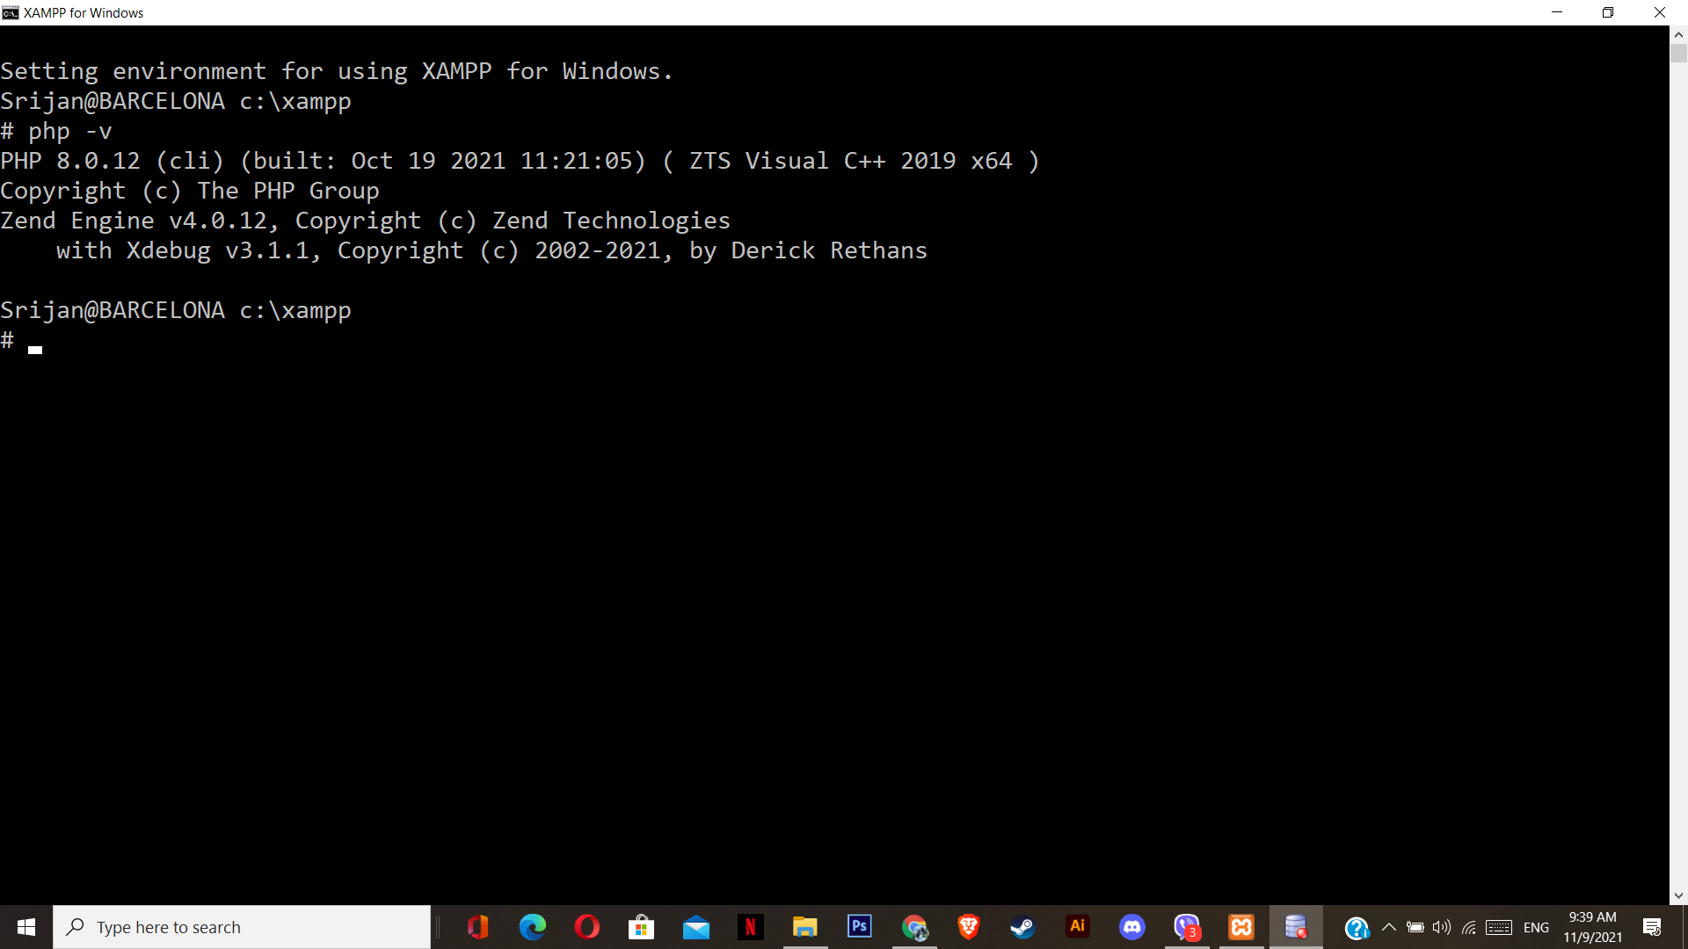

**Added Xdebug in IDE.**

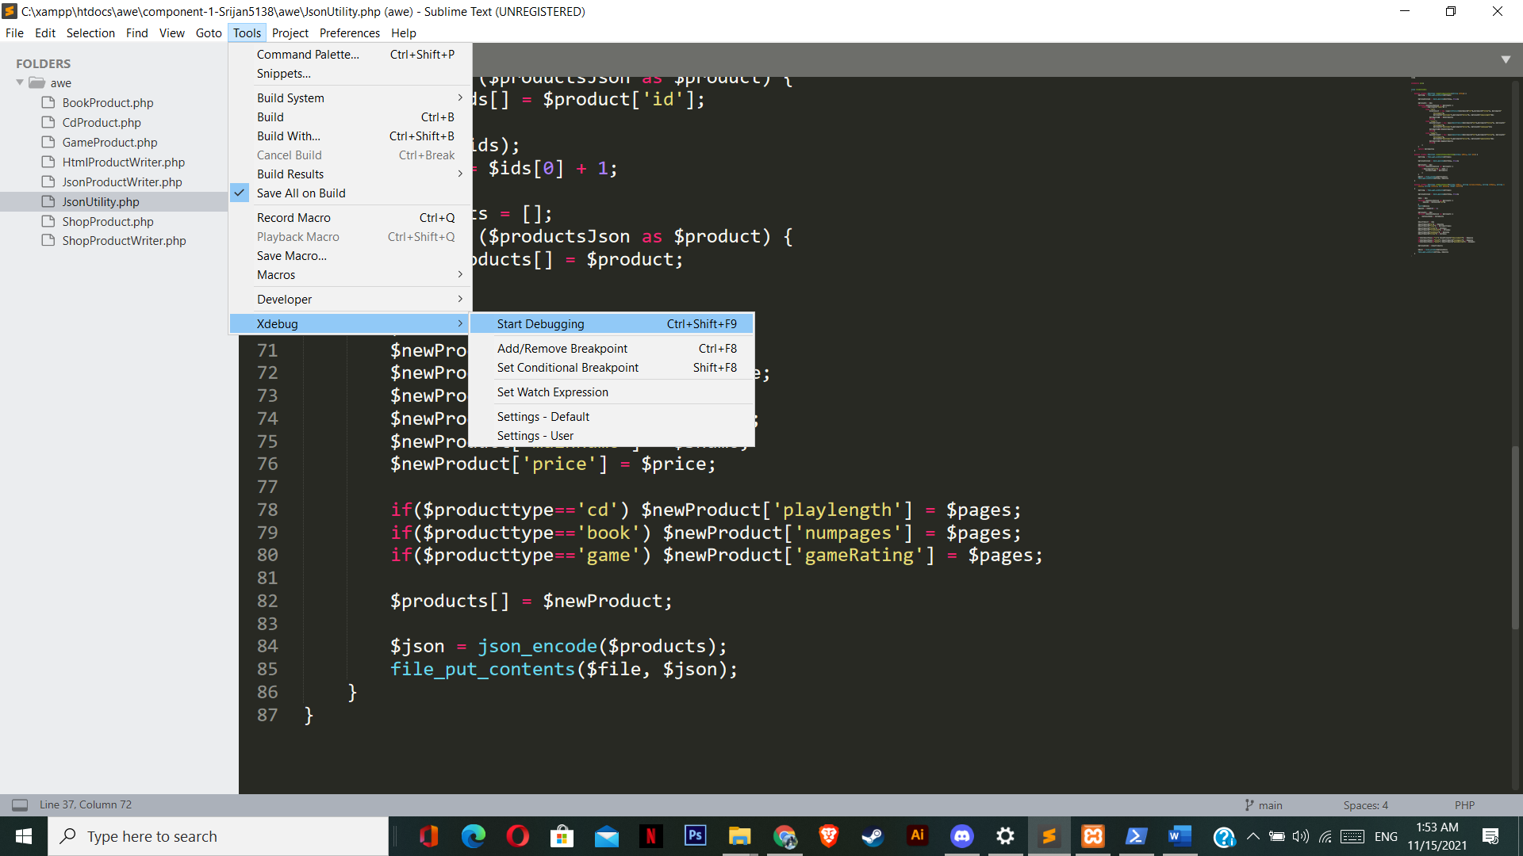

**Screenshots of frontend and changes made in source code.**

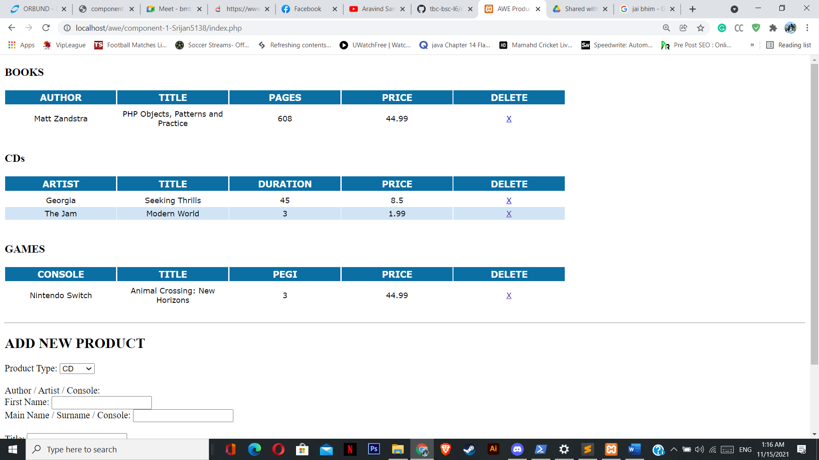

**GameProduct.php**

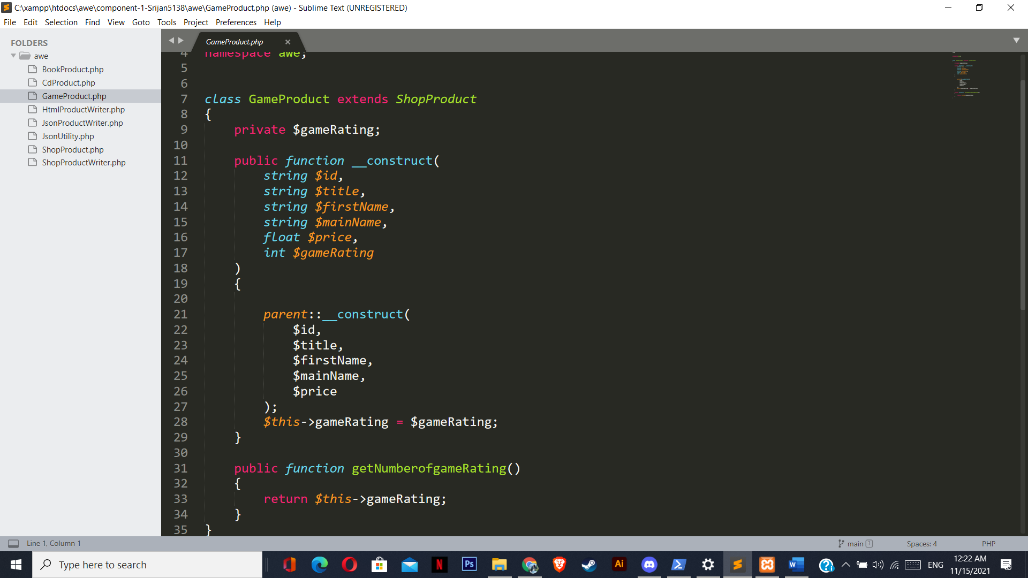

**HtmlProductWriter.php**

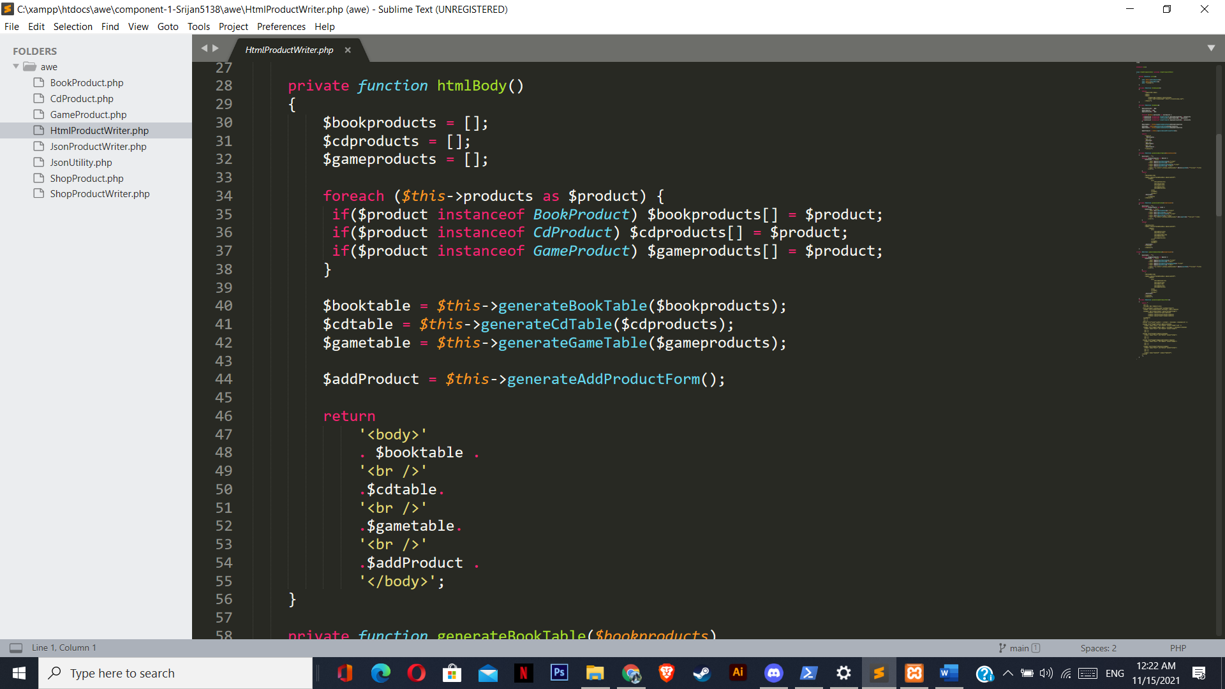

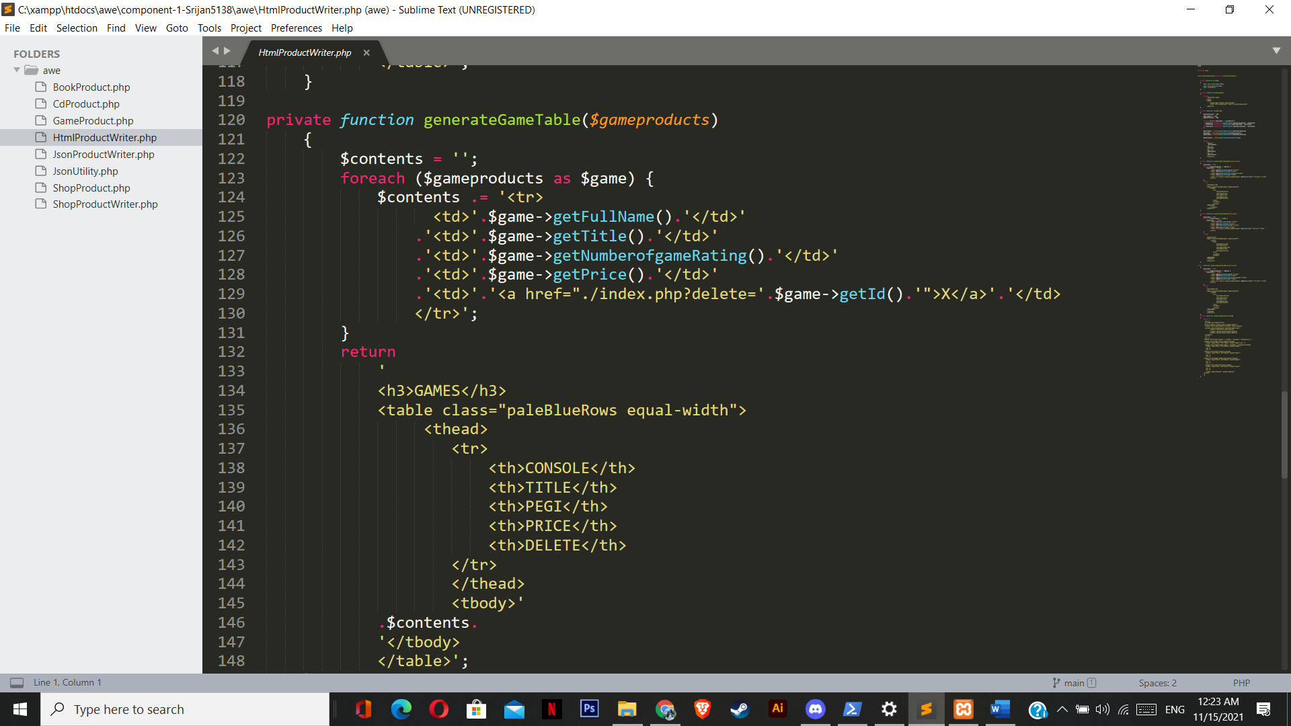

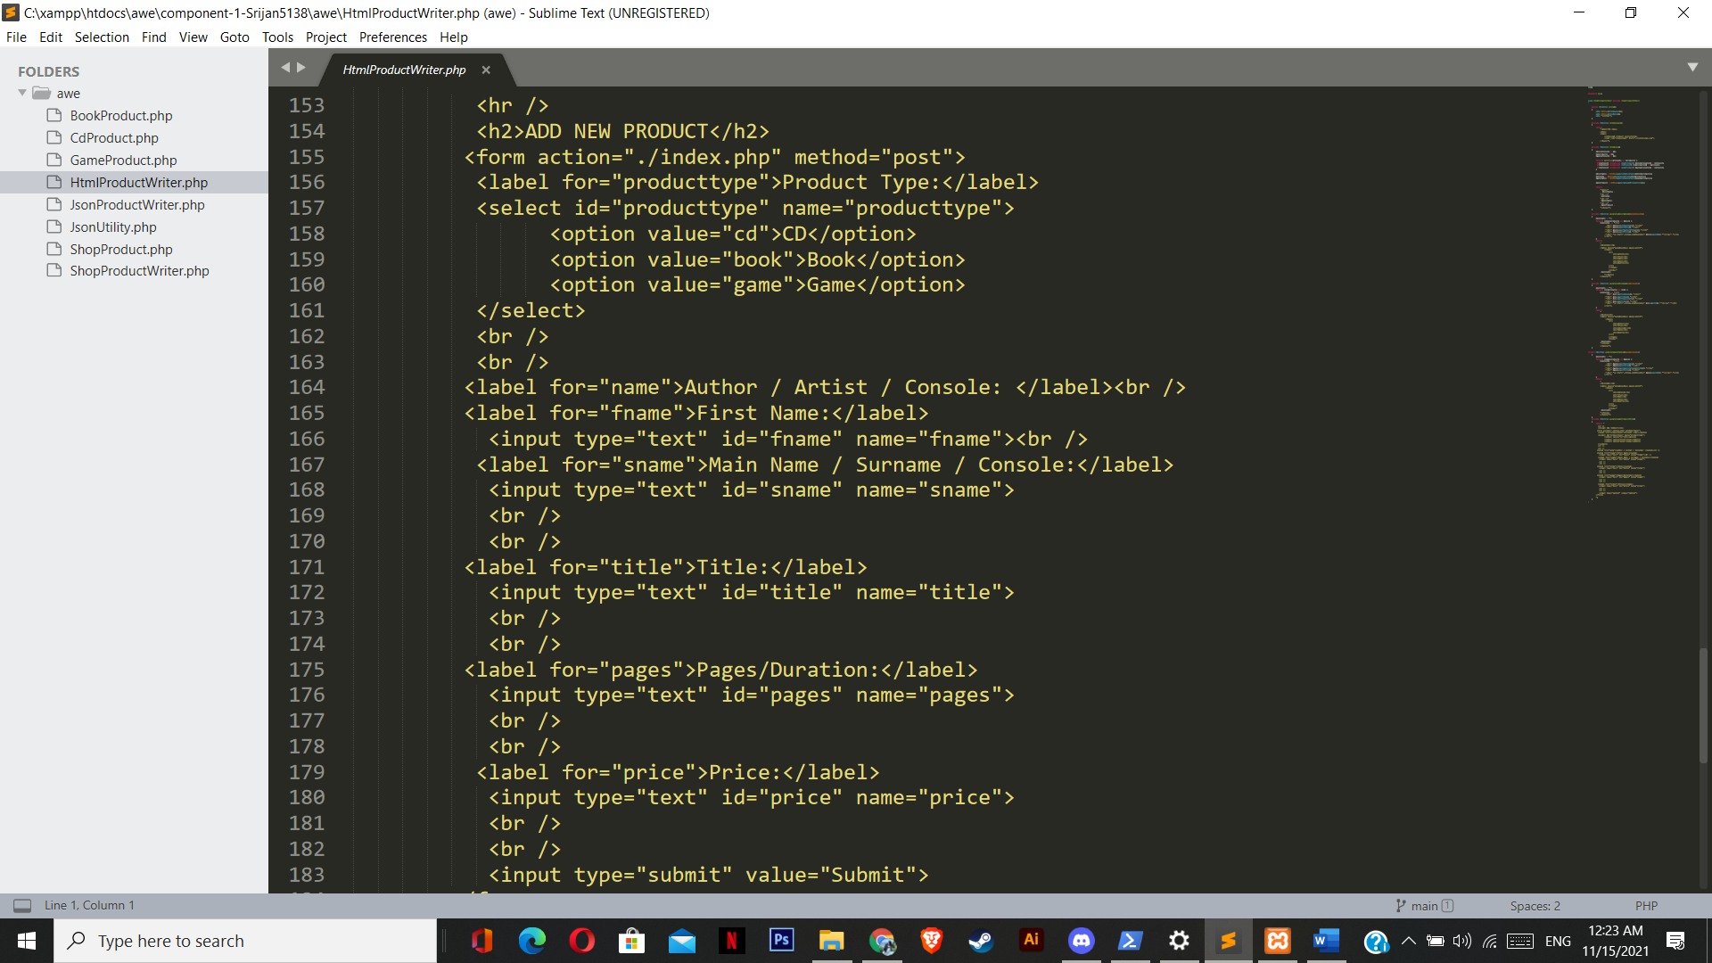

**JsonProductWriter.php**

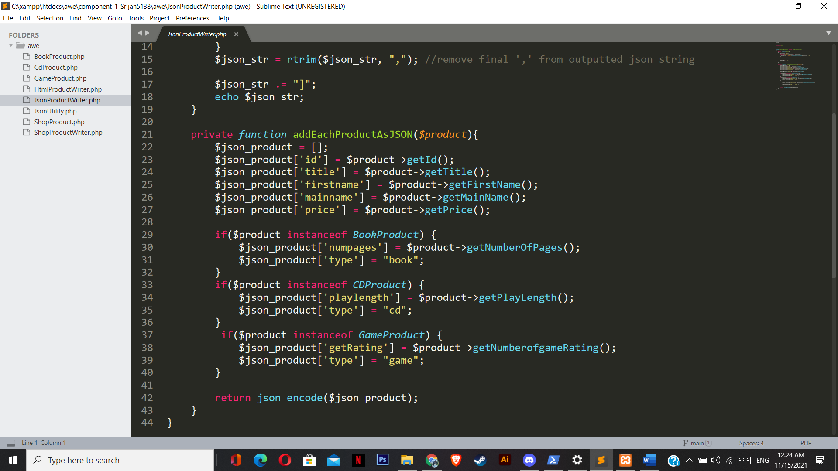

**JsonUtility.php**

